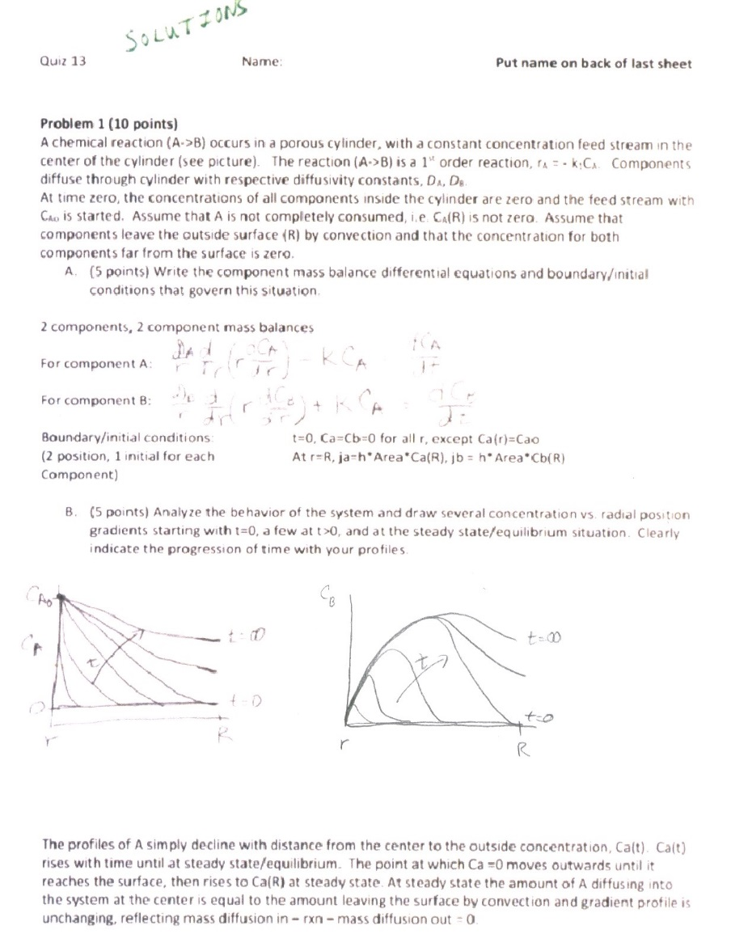

The profiles of B initially have a peak/hump that moves outwards until it reaches the surface, then settles down to a steady state/equilibrium value Cb(R) at the surface. At steady state the amount of B diffusing out of the system at the surface is equal to the amount generated in the system by reaction and the gradient profile is unchanging, reflecting rxn – mass diffusion out = 0.

Note: The shape of the hump/peak depends on whether the rate of reaction and diffusion rate of A is faster than the diffusion rate of B. If so, there is a sharp boundary, if not a more diffuse hump.

**Problem 2 (15 points)**

For an electrical clothes dryer as the system (see picture below):

1. (6 points) Write the component mass balances for the system

3 components: cotton, water, air -> 3 component mass balances

Air: F3*x3a – F4*x4a =0

Cotton: F1*x1c – F2*x2c = 0

Water: F1*x1w +F3*x3w– F2*x2w – F4*x4w = 0

1. (9 points) Write the energy balance for the system, using the mass balances (part A)

Please use nomenclature given below/on drawing.

Note: sensible enthalpy = m*Cp*(T-Tref) Enthalpy of vaporization = Hv

To simplify the equations, assume the reference temperature = T1

So no enthalpy in either streams 1 or 3 (all thermal enthalpy, mass*Cp*(T1-Tref)=0)

Enthalpy in stream 3 Enthalpy out in stream 4 Enthalpy out in stream 2

F3*x3w*Hv - F4*{x4a*Cpa*(T2-T1)+x4w*[Cp2*(T2-T1)+Hv]} – F2*{x2c*Cpc*(T2-T1)+x2w*Cpw*(T2-T1)} + F5 = 0

Energy in stream 5

Alternatively, if reference temperature = 0

Enthalpy entering in stream 1 Enthalpy entering in stream 3

F1*{x1c*Cpc*(T1)+x1w*Cpw*T1} + F3*{x3w*[Cp2*T1+Hv]+X3a*Cp1*T1} –

Enthalpy exiting in stream 4 Enthalpy exiting in stream 2 Energy in in stream 5

F4*{x4a*Cpa*T2+x4w*[Cp2*T2)+Hv]} – F2*{x2c*Cpc*(T2)+x2w*Cpw*(T2)} + F5=0